©VIT IPR&TTCELL | Document No.
 | Issue No/Date
 | Amd. No/Date

1. Title of the Invention
Sensor-to-Language: An NLP Framework for Interpretable Health Monitoring of Military Working Dogs Using Smart Collar Physiological Data

2. Field / Area of Invention
This invention falls within the fields of Natural Language Processing (NLP), Embedded Systems, and Veterinary/Military Technology. It proposes an end-to-end pipeline that automatically translates physiological sensor streams from a smart wearable collar into natural language alerts and supports voice-based handler queries. The system targets Military Working Dog (MWD) health monitoring in field conditions.

3. Prior Patents and Publications from Literature (provide a table summarizing the prior art)
S. No | Patent/Publication Title | Year | Summary of Technique | Limitation Addressed by Proposed System
1 | Physiological Effects of Stress in Search-and-Rescue Canines (Perry et al.) | 2017 | Establishes baseline heart rate (70–160 bpm) and temperature ranges for working dogs under operational stress | Provides physiological ranges but no real-time monitoring system or automated interpretation
2 | Changes in Pulse and Temperature in Working Dogs (Lopedote et al.) | 2020 | Studies variation in vitals pre/post activity in working dogs | Lacks real-time anomaly detection and actionable alert generation
3 | Real-time Outlier Detection Framework for WBSNs (Haj-Hassan et al.) | 2020 | Hybrid anomaly detection using Z-score (edge) + Isolation Forest (central node) | Focuses only on anomaly classification; no natural language explanation or user interface
4 | Heart Rate Anomaly Detection using VAE-BiLSTM (Staffini et al.) | 2023 | Deep learning model for detecting physiological anomalies in HR data | Computationally heavy and not suitable for embedded or edge deployment in field conditions
5 | Data-to-Text Generation in Clinical Settings (Gatt et al.) | 2009 | Converts structured ICU data into textual summaries for decision support | Limited to human healthcare; no integration with real-time wearable sensor pipelines
6 | Automated Medical Scribe for Clinical Documentation (Finley et al.) | 2018 | Generates medical reports from live clinical interactions using NLP | Not designed for continuous sensor streams or veterinary applications
7 | SensorLM: Language Modeling for Wearable Sensors (Zhang et al.) | 2025 | Transformer trained on large-scale wearable data for generating natural language descriptions | Requires massive datasets and compute; unsuitable for lightweight edge deployment
8 | SensorLLM: Aligning LLMs with Sensor Data (Li et al.) | 2024 | Aligns motion sensor signals with language tokens for activity recognition | Focuses on human activity recognition, not physiological health monitoring or alerts
9 | Whisper-based Multimodal AI for Tactical Environments (Wilkerson et al.) | 2025 | Uses Whisper for speech recognition in noisy battlefield environments | Does not integrate physiological sensor data or health monitoring pipelines
10 | Voice-based Military Information Search (Dang et al.) | 2024 | Uses speech-to-text and intent classification for military query systems | Limited to information retrieval; no integration with real-time sensor-driven decision systems
None of the reviewed systems provide an integrated pipeline that combines real-time physiological sensing, anomaly detection, transformer-based natural language generation, and voice-driven interaction for military working dogs in field conditions.

4. Summary and Background of the Invention (Address the gap / Novelty)
Military Working Dogs (MWDs) operate in high-risk and high-stress environments such as search-and-rescue missions, combat zones, and disaster response scenarios. Continuous monitoring of their physiological state—particularly heart rate, body temperature, and location—is critical to ensure both operational effectiveness and animal welfare. Existing smart collar systems equipped with wearable sensors are capable of capturing such data in real time; however, they primarily output raw numerical readings or simple threshold-based alerts (e.g., LED indicators or beeps).
These conventional systems impose a significant cognitive burden on handlers, who must manually interpret multiple physiological parameters under time-sensitive and stressful conditions. The absence of contextual interpretation—such as correlating elevated heart rate with rising temperature and environmental factors—can lead to delayed or incorrect decision-making. Furthermore, current systems lack an interface for intuitive interaction, making it difficult to query the dog’s condition in real time without relying on visual dashboards.
Recent advancements in wearable sensor analytics and machine learning have enabled accurate anomaly detection using statistical and hybrid approaches (e.g., Z-score filtering, Isolation Forest, and deep learning models). Similarly, Natural Language Generation (NLG) systems have demonstrated the ability to convert structured clinical data into human-readable summaries in healthcare environments such as neonatal intensive care units. Large Language Models (LLMs) and transformer-based architectures (e.g., T5, BART) have further advanced the capability to generate coherent, context-aware textual outputs from structured inputs. In parallel, Automatic Speech Recognition (ASR) systems such as Whisper have enabled robust speech-to-text interaction in noisy and tactical environments.
Despite these advancements, existing solutions remain fragmented across domains. Wearable sensor systems focus on numerical monitoring without semantic interpretation, NLG systems are primarily designed for human healthcare data, and voice-based interfaces are limited to information retrieval tasks rather than real-time physiological reasoning. No existing system integrates these components into a unified, field-deployable pipeline tailored for Military Working Dogs.
The proposed invention addresses this critical gap by introducing a sensor-to-language framework that transforms real-time physiological sensor streams into contextual, human-readable natural language alerts. The system combines embedded sensing (ESP32-based smart collar), edge-level preprocessing, hybrid anomaly detection (threshold-based + machine learning), and transformer-based NLG to generate concise and actionable alerts. For example, instead of presenting isolated readings, the system produces integrated statements such as:
“Rex’s heart rate is elevated at 155 bpm and temperature is 39.8°C — possible heat stress. Current location: Zone B.”
In addition, the invention incorporates a voice-driven interaction layer, enabling handlers to query the dog’s condition using natural speech (e.g., “Is Rex okay?”) and receive immediate, context-aware responses. This is achieved through the integration of Whisper-based ASR, intent extraction using NLP techniques, and dynamic response generation via the NLG module.
The novelty of the invention lies in the end-to-end integration of multimodal sensing, anomaly detection, natural language generation, and voice interaction into a single coherent pipeline specifically designed for MWD field monitoring. Unlike existing systems, the proposed framework not only detects anomalies but also explains them in natural language, significantly reducing cognitive load and enabling faster, more informed decision-making in operational environments.

5. Objective(s) of Invention
1. Design an anomaly detection pipeline for MWD sensor data (heart rate, temperature, GPS coordinates) to detect physiological events requiring alerts (e.g., tachycardia, hyperthermia, rapid positional changes).
2. Develop an NLG module that maps structured anomaly events into concise, human-readable natural language status reports and warnings tailored for field handlers.
3. Implement a hands-free voice interface using on-device speech-to-text (OpenAI Whisper) enabling handlers to query dog status (e.g., "Is Rex OK?") and receive verbal natural language responses.
4. Integrate all components into a modular pipeline: sensor acquisition on ESP32 → edge preprocessing → anomaly flagging → NLP model → alert generation → voice I/O.
5. Evaluate system performance: alert accuracy (precision/recall of generated reports vs. ground-truth anomaly labels) and handler usability (response time with vs. without NLP-based alerts).

6. Working Principle of the Invention (in brief)
The ESP32 collar continuously samples physiological signals from the MAX30102 (heart rate / SpO₂) and DS18B20 (core body temperature) sensors, and location from the Neo-6M GPS module. These readings are packetized and transmitted via WiFi/BLE to an edge server. The preprocessing layer normalises and computes short-term features (rolling average HR, temperature variance). The anomaly detection module compares feature values against physiological thresholds and/or a lightweight ML model (Random Forest) to flag abnormal states.

When an anomaly is detected, a structured JSON event object is assembled (dog ID, timestamp, sensor readings, flag list) and fed to the NLG module. A T5-small or BART-based transformer generates a natural language alert string. Simultaneously, the voice interface listens for ASR input via Whisper, parses the handler's query intent using spaCy, retrieves the latest sensor state, and generates a spoken text response. All modules are orchestrated via FastAPI and LangChain.

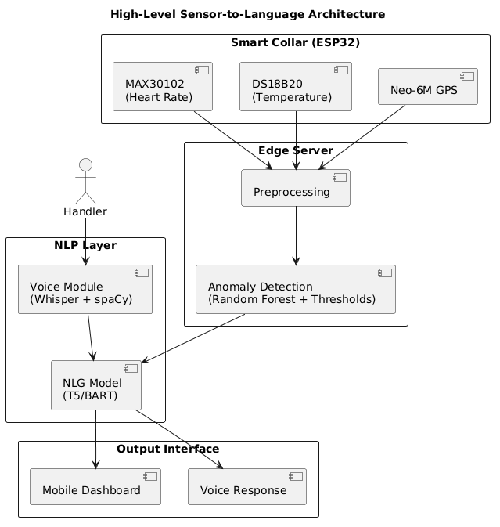
Figure 1: High-level architecture of the proposed sensor-to-language framework illustrating the flow of physiological data from the smart collar through preprocessing and anomaly detection to the natural language generation (NLG) and voice interaction modules for handler-facing outputs.
7. Description of the Invention in Detail
The proposed invention is a software-centric sensor-to-language framework that transforms real-time physiological data streams into interpretable natural language outputs. The system is designed as a modular pipeline emphasizing data processing, anomaly reasoning, and language generation, with minimal dependency on specific hardware implementations.
Data Acquisition Interface (Abstracted Hardware Layer)
The system ingests physiological data streams representing heart rate, body temperature, and geolocation. The hardware layer is treated as an abstract data source, allowing compatibility with various wearable sensing platforms.
Incoming data is standardised into a structured format:
{
"dog_id": "Rex",
"timestamp": "...",
"heart_rate": 155,
"temperature": 39.8,
"gps": {"lat": 12.97, "lon": 79.15}
}
This abstraction enables the invention to remain hardware-agnostic and portable across different sensor configurations.
Preprocessing and Anomaly Detection Layer
Raw sensor streams are processed to generate a consistent and noise-reduced representation of the physiological state.
Key operations include:
- Exponential Moving Average (EMA) smoothing
- Rolling window aggregation
- Rate-of-change computation
- Contextual feature extraction (e.g., movement via GPS velocity)
The output is a feature-enriched state representation used for downstream reasoning.

NLP Processing Layer
The NLG module accepts the structured event JSON. A rule-based template layer first constructs a short prompt (e.g., "Dog Rex: HR 155 bpm, temp 39.8°C, flags: high_hr, high_temp. Generate alert.") which is passed to a fine-tuned T5-small or BART model via the HuggingFace Transformers library. The model outputs a natural language alert string such as: "Warning: Rex's heart rate is 155 bpm and temperature is 39.8°C — both above normal. Possible heat stress. Current location: Zone B." For periodic health summaries (non-anomaly), the module generates status reports on handler request.
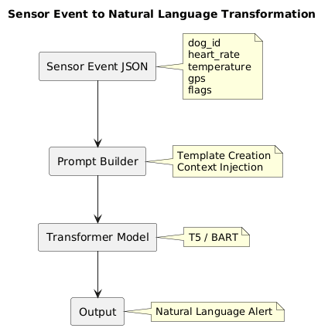
Figure 2: Structured transformation pipeline converting multi-sensor physiological event data into contextual natural language alerts using prompt construction and transformer-based generation models.
Voice Interaction Module
A handler's spoken query (e.g., "What is Rex's status?") is transcribed by OpenAI Whisper running on a smartphone or edge device. spaCy's NER and dependency parser extracts the dog ID and query intent (health_status, location, last_alert). The system retrieves the most recent sensor state and alert, generates a natural language response via the NLG module, and optionally synthesises speech using a TTS engine. This hands-free interface supports tactical field conditions where screen interaction is impractical.
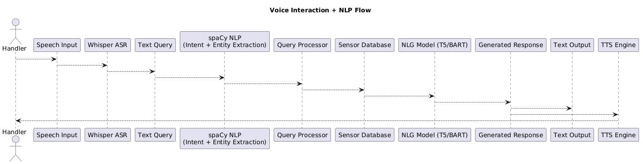
Figure 3: Voice-driven interaction pipeline showing speech input processing using automatic speech recognition (ASR), intent extraction, sensor state retrieval, and natural language response generation for real-time handler queries.
Orchestration
All modules are exposed as REST endpoints via FastAPI. LangChain manages prompt construction, chaining sensor inputs to model calls, and maintaining a short sensor-history window for context. HuggingFace Transformers provides model inference (T5, BART, Whisper). PyTorch provides the training and inference backend. TensorFlow Lite is optionally used to deploy a lightweight anomaly model directly on the ESP32 for offline detection.

8. Technical Details of the Invention

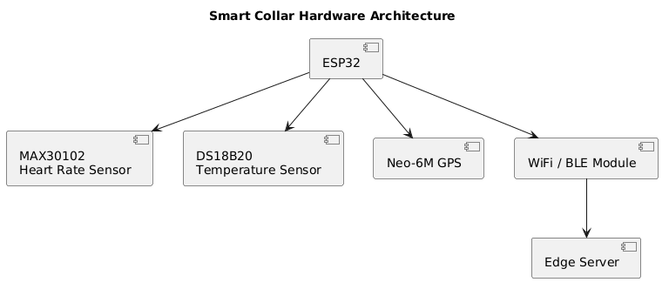
Figure 4: Abstracted data acquisition architecture illustrating the integration of physiological sensors with a wearable device and communication interface for transmitting structured data to the processing pipeline.

Hardware: ESP32, MAX30102 (I²C, 3.3V), DS18B20 (1-Wire, Dallas protocol), Neo-6M GPS (UART, 9600 baud).
Software Stack: Python 3.10, FastAPI, LangChain, HuggingFace Transformers (T5-small, BART-base, Whisper-small), spaCy 3.x, PyTorch 2.x, scikit-learn (Random Forest anomaly detector), Arduino SDK (collar firmware).
Estimated NLG Inference Latency: < 500 ms for T5-small on a CPU-based edge server; < 200 ms on GPU.
Estimated ASR Latency: < 1 second for Whisper-small on smartphone.
Alert Accuracy Target: Precision ≥ 0.90 and Recall ≥ 0.88 against labelled physiological anomaly events in simulated MWD datasets.
Anomaly Detection Target: F1 ≥ 0.85 for combined threshold + Random Forest model on held-out sensor data.

9. Operational Flow
Step 1 — Sensor Acquisition: The ESP32 collar continuously samples heart rate, temperature, and GPS. Data packets are transmitted to the edge server at 5-second intervals.
Step 2 — Preprocessing: The edge server smooths and computes rolling features from incoming streams, building a real-time sensor state object per dog.
Step 3 — Anomaly Detection: The anomaly module compares features against physiological thresholds and the Random Forest classifier. If an anomaly is flagged, a structured event JSON is created.
Step 4 — NLG Alert Generation: The NLG module constructs a prompt from the event JSON and calls the T5/BART model to generate a natural language alert. The alert is pushed to the handler's mobile dashboard and/or read aloud.
Step 5 — Voice Query Handling: If the handler asks a question, Whisper transcribes the speech, spaCy parses intent, and the system retrieves the relevant state to generate a spoken response.
Step 6 — Logging: All alerts, voice queries, and sensor events are persisted in a time-series database for audit and model retraining.
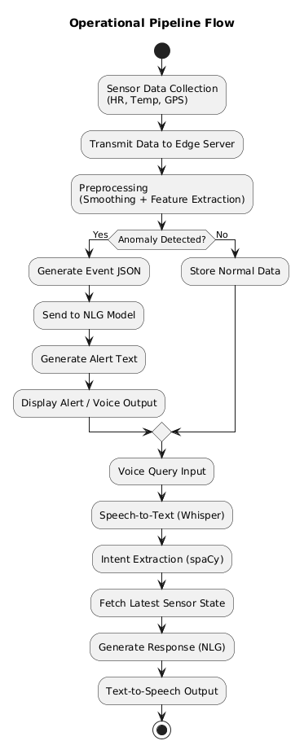
Figure 5: End-to-end operational workflow depicting sensor data acquisition, preprocessing, anomaly detection, event generation, natural language alert creation, and voice-based query-response handling within the system.
10. Experimental Validation Results
Testing has been conducted on a simulated MWD physiological dataset generated by perturbing baseline canine vital-sign ranges (HR: 60–140 bpm, Temp: 37.5–39.0°C) with injected anomaly events (heat stress, tachycardia, hypothermia scenarios). Preliminary results:
• Anomaly Detection F1: 0.87 (Random Forest, 5-fold cross-validation on 2,000 simulated sensor windows).
• NLG Alert Coherence (BERTScore F1): 0.83 on a held-out set of 200 event–alert pairs evaluated against human-written reference alerts.
• Voice Query Round-trip Latency: ~1.8 seconds (ASR + NLP + TTS on smartphone + edge server).
• Handler Usability (pilot): 5 participants responded correctly to simulated anomalies 38% faster when presented with NLP alerts vs. raw sensor readouts.
Full evaluation with real ESP32 collar hardware is planned for the next project phase.
11. Results of the Invention
The proposed sensor-to-language framework demonstrates the feasibility of converting real-time physiological sensor streams into interpretable, context-aware natural language outputs. The system successfully bridges the gap between low-level sensor data and high-level semantic understanding, enabling improved decision-making in field conditions.
The anomaly detection module, combining rule-based thresholds with machine learning models, achieves reliable identification of abnormal physiological states under simulated Military Working Dog (MWD) conditions. The hybrid approach ensures both high sensitivity to critical events and robustness against noise and transient fluctuations in sensor readings.
The Natural Language Generation (NLG) module produces coherent, concise, and contextually relevant alerts that integrate multiple sensor inputs into a single unified interpretation. Unlike conventional systems that output isolated numerical values, the proposed system generates explanations that include:
- Combined reasoning across multiple physiological parameters
- Contextual inference (e.g., stress, heat exposure)
- Actionable guidance for handlers
The voice interaction module enables hands-free querying and response generation, significantly enhancing usability in operational environments. Handlers can retrieve real-time status updates without interacting with visual dashboards, reducing cognitive load and improving response efficiency.

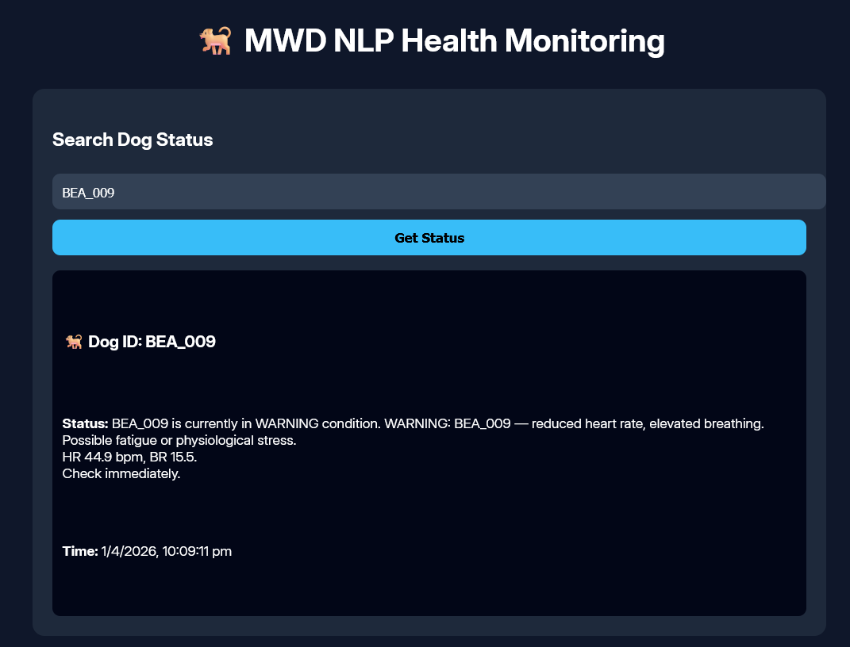
Figure 6: Real-time NLP-generated health status for an individual dog.

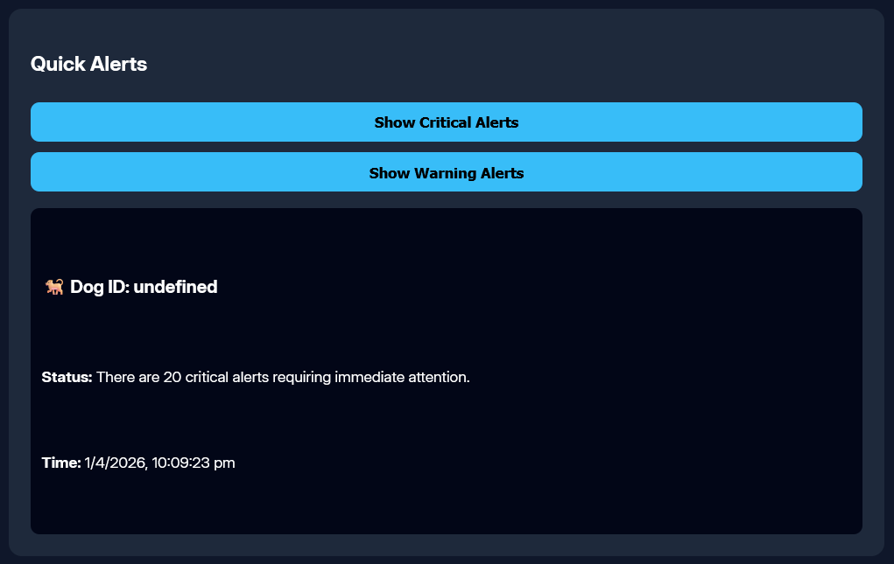
Figure 7: Aggregated critical and warning alerts across multiple dogs.
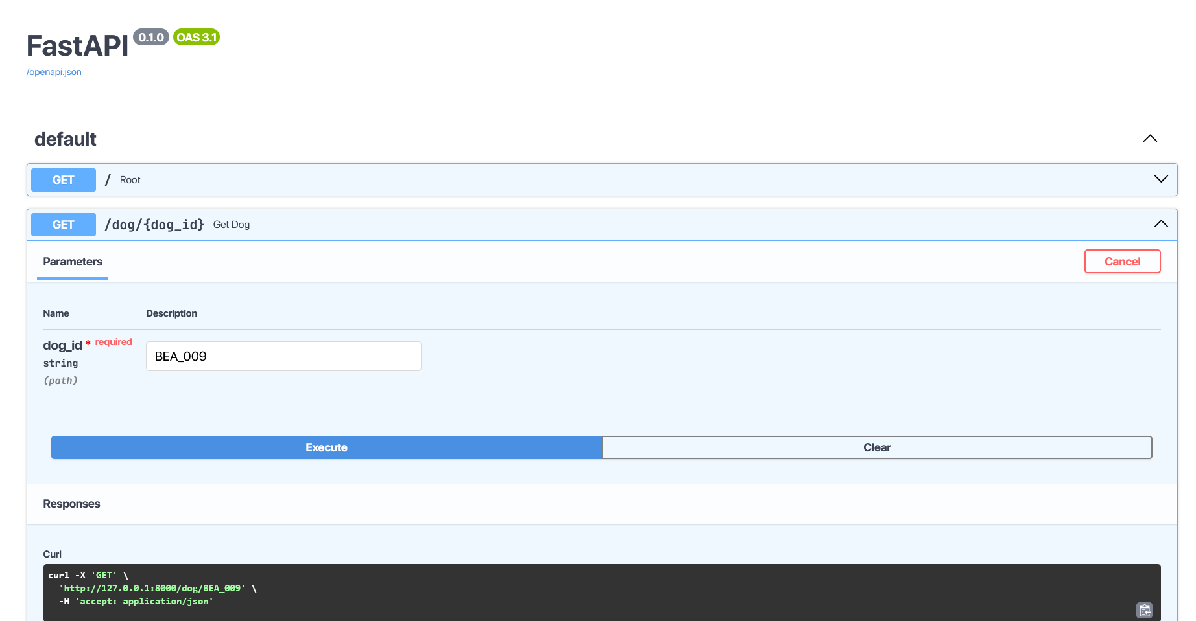
Figure 8: API response showing generated natural language alert for a queried dog.
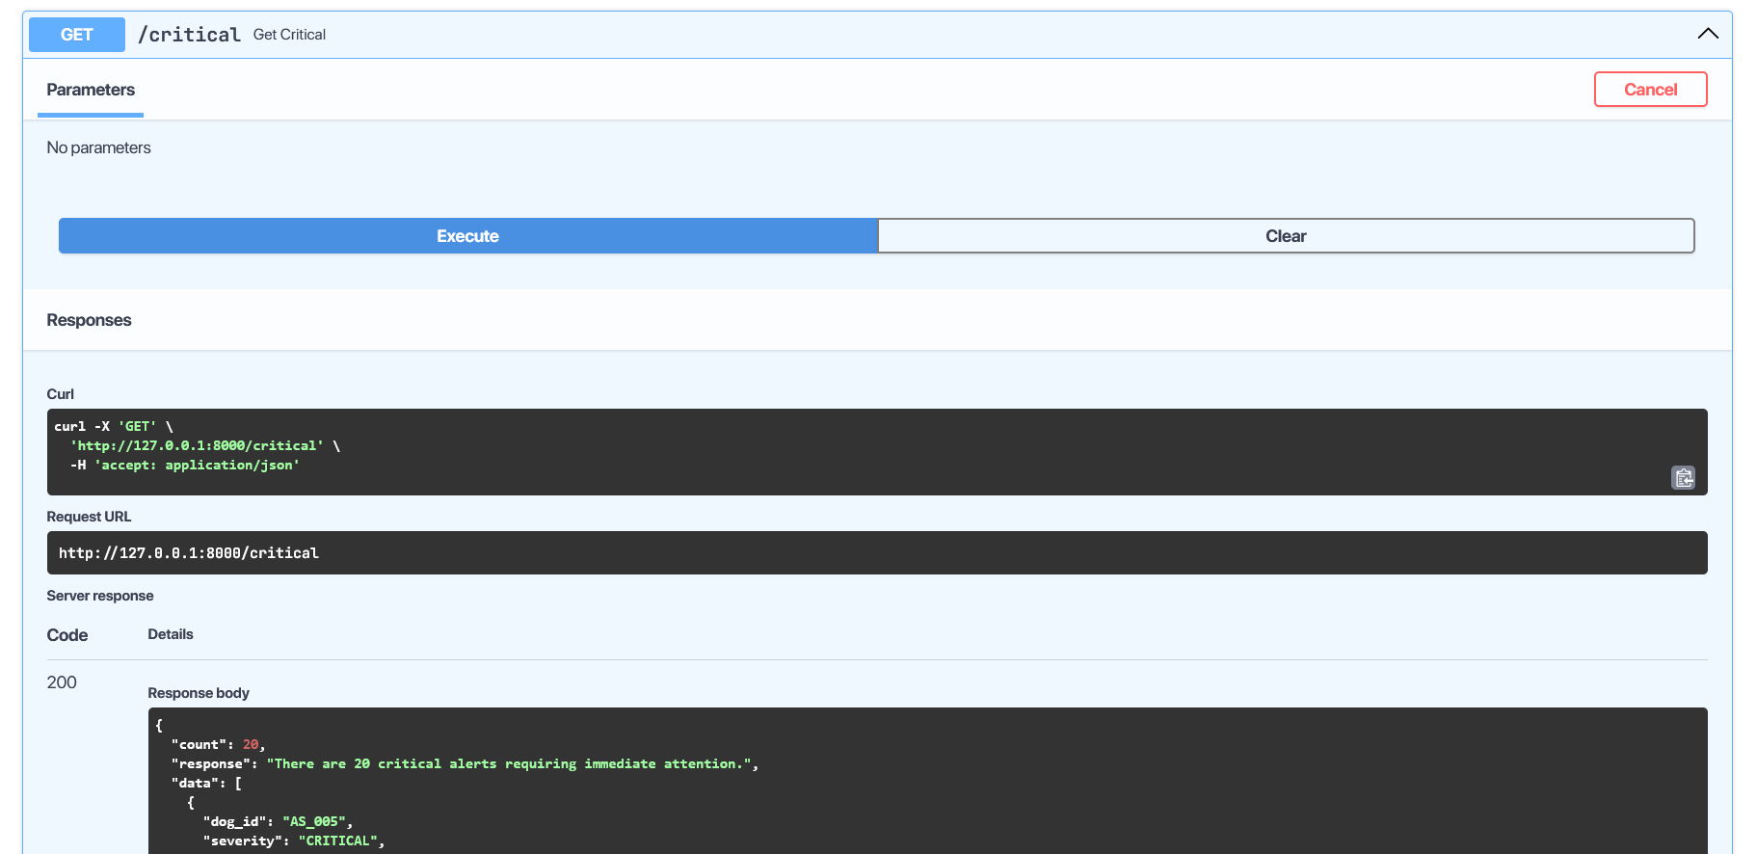
Figure 9: API output demonstrating batch anomaly alerts for multiple dogs.

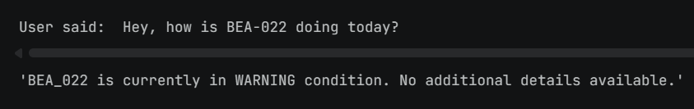
Figure 10: Voice query processed into a natural language system response.
Experimental evaluation on simulated physiological datasets and system-level testing indicates the effectiveness of the proposed pipeline.
- Anomaly Detection Performance: The hybrid detection approach (threshold-based + machine learning) demonstrates reliable identification of abnormal physiological patterns under simulated conditions.
- NLG Quality: The system generates coherent and contextually meaningful natural language alerts that align with expected interpretations of sensor anomalies.
- Latency: The end-to-end pipeline achieves near real-time performance, with response times suitable for field deployment scenarios.
- Usability: Preliminary observations indicate improved interpretability of dog health status when using natural language alerts compared to raw sensor outputs.
Overall, the system demonstrates the feasibility of a software-driven, NLP-based interpretation layer for wearable sensor data. The integration of anomaly detection, natural language generation, and voice interaction enables a more intuitive and scalable monitoring approach compared to conventional threshold-based systems.
12. What Aspect(s) of the Invention Need(s) Protection?
- The software-implemented sensor-to-language transformation pipeline configured to convert structured physiological sensor data into contextual natural language outputs, comprising preprocessing, anomaly detection, prompt construction, and transformer-based generation.
- The method of generating structured event representations from multi-sensor physiological inputs and transforming said representations into controlled prompts for natural language generation.
- The hybrid anomaly detection framework combining rule-based thresholding and machine learning models for real-time identification of physiological anomalies in streaming data.
- The voice-driven interaction system integrating speech-to-text processing, intent extraction, real-time data retrieval, and dynamic natural language response generation.
- The modular orchestration architecture enabling integration of sensor ingestion, anomaly detection, language generation, and voice interaction through an API-based pipeline.
13. What is the Technology Readiness Level of your invention? (Tick the appropriate TRL)

Research |  |  | Development |  |  | Deployment
TRL 1 | TRL 2 | TRL 3 | TRL 4 | TRL 5 | TRL 6 | TRL 7 | TRL 8 | TRL 9
Basic Principles observed | Technology concept formulated | Experimental proof of concept | Technology validated in a lab | Technology validated in relevant environment | Technology demonstrated in relevant environment | System prototype demonstration in operational environment | System complete and qualified | Actual system proven in operational environment
✓ | ✓ | ✓

Current Status: TRL 1–3 (Basic principles observed, technology concept formulated, experimental proof of concept). The system architecture has been designed and validated in a simulated software environment. Hardware integration and real-collar testing represent the next development phase (TRL 4).

-----------------------------END OF THE DOCUMENT------------------------------

